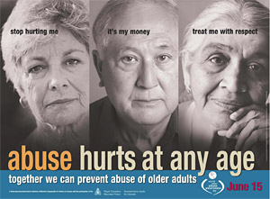

ELDER ABUSE: Red Flags

And How to Help Older Adults

March 1, Thursday 1:00pm—3:00pm

- Recognize the red flags of elder abuse, neglect and exploitations
- Learn effective ways to talk with clients and families
- Understand if you are a mandated reporter, and your obligations
- Know how and when to report, and what happens after a report

1.5 CEUs

Karin Taifour, MA, LMHC, GMHS, has provided training for the county and state bar associations, guardian and GAL programs, Adult Protective Services, hospitals, clinics, mental health agencies, and social service providers and has also taught graduate level courses. She is an active member of the Elder Abuse Council of Seattle/King County.

WHERE: Enumclaw Senior Center, 1350 Cole Street, Enumclaw
WHEN: Thursday, March 1, 1:00pm—3:00pm
REGISTER: Enumclaw Senior Center, 360-825-4741; jnickum@ci.enumclaw.wa.us

Case Managers, Assisted Living Facility staff, Adult Family Home, all Senior Service Providers, and all who work with the public are all encouraged to attend. These trainings have been approved for 1.5 CEUs for WA State Lic Mental Health Counselors, Lic Marriage and Family Therapists, and Lic Social Workers. WMHCA Provider #1708

SPONSORED BY Enumclaw Senior Center, City of Enumclaw; Farr Law Group

